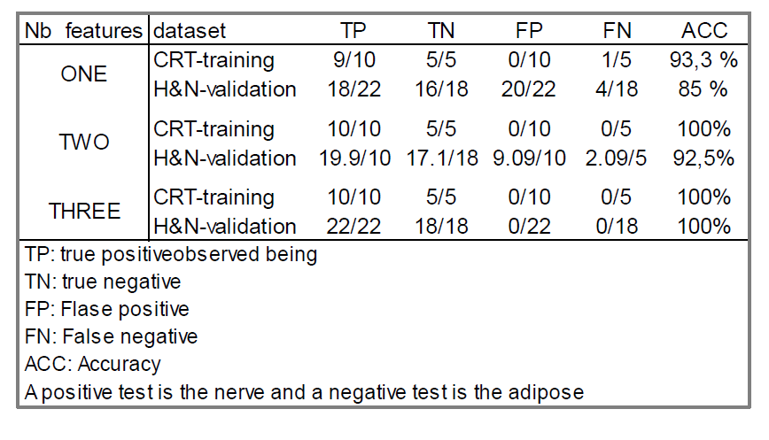

|  |  |  |  |  |  |  |
| --- | --- | --- | --- | --- | --- | --- |
| # of Features | Dataset | TP | TN | FP | FN | ACC(%) |
| 1 | Training | 15/32 | 1/32 | 1/32 | 15/32 | 93.75 |
| Test | - | - | - | - | - |
| 2 | Training | 15/32 | 1/32 | 0/32 | 16/32 | 96.88 |
| Test | - | - | - | - | - |

DMI

|  |  |  |
| --- | --- | --- |
| # of Features | Dataset | Accuracy |
| 1 | Training | 87.50 |
| Age, TH_G_75 |
| Test |  |
|  |
| 2 | Training | 93.75 |
| Age, TH_G_75 |
| Test |  |
|  |

|  |  |  |
| --- | --- | --- |
| # of Features | Dataset | Sensitivity |
| 1 | Training | 1 |
| Age, Sl_G_120_0 |
| Test |  |
|  |
| 2 | Training | 1 |
| Age, Sl_G_120_0 |
| Test |  |
|  |

|  |  |  |
| --- | --- | --- |
| # of Features | Dataset | Specificity |
| 1 | Training | 1 |
| Sl_G_120_60, IGM_0_60 |
| Test |  |
|  |
| 2 | Training | 1 |
| Sl_G_120_60, IGM_0_60 |
| Test |  |
|  |